Task 1 : Write a query which uses join and let us know the internal processing of the query.
Query:- select student.s_name ,marks.score,details.school_id from student inner join marks on student.s_id=marks.s_id inner join details on details.school_id=marks.school_id where student.s_id=3;
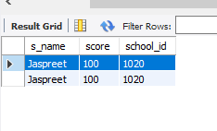
Order of Execution:-
Parsing
Step 1 :- Syntax Check
Step 2 :- Semantic Check
Step 3 :- Shared Pool Check
Step 4 :- Code Optimization
Step 5 :- Row Source Generation
Step 6 :- Execution
Order of Execution with Referance of above Query:
Step 1- From Clause Should get executed first to list the table and also person join on tables.
Query:- select student.s_name ,marks.score,details.school_id from student inner join marks on student.s_id=marks.s_id inner join details on details.school_id=marks.school_id where student.s_id=3;
Step 2- Where Clause executed after from clause to filter data on given condition .
Query:- select student.s_name ,marks.score,details.school_id from student inner join marks on student.s_id=marks.s_id inner join details on details.school_id=marks.school_id where student.s_id=3;
Step 3- Suppose we also have Group by in our query then after the where clause group by executed after where clause.
Query:- select student.s_name ,marks.score,details.school_id from student inner join marks on student.s_id=marks.s_id inner join details on details.school_id=marks.school_id Group by s_name;
Step 4- After Group by the Having which is like where clause but it get executed after the group By clause.
Step 5- After all this execution the Select statement get executed to display the output of query we can also define limited column which we want to display.
Step 6- At last Order by get executed to set the Order of output data in Asecending or Descending form.
Query:- select student.s_name ,marks.score,details.school_id from student inner join marks on student.s_id=marks.s_id inner join details on details.school_id=marks.school_id order by s_name;

Task 2 :- Write a query to calculate the age based on the date of birth value given in the column.
Table Creation:- create table user (name varchar(20), dob date);
insert into user values("Vinod",19990331),("Satish",19970212),("Arush",19950331);
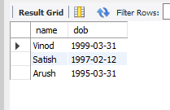
Query to Calculate Age:-
SELECT name , DATE_FORMAT(FROM_DAYS(DATEDIFF(now(),dob)), '%Y')+0 AS Age from user ;
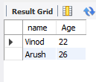
Task 3:-
Write a query which demonstrates date related functions.[Minimum 15].
insert into user value("Satish" ,19990331,1),("Arush" ,19970420,2),("Vinod" ,19980321,3);
select * from user;
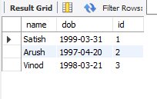

- Select now()-> Return current date and Time.
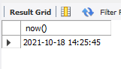
- Select curdate()-> Return Current date.
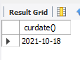
- Select curtime()-> Return Current Time.
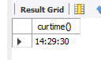
- DATE(): Extracts the date part of a date or date/time expression.
SELECT Name, date(dob) AS BirthDate FROM user;
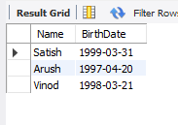
- EXTRACT(): Returns a single part of a date/time.
SELECT Name, Extract(DAY FROM dob) AS BirthDay FROM user;
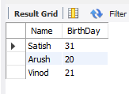

- DATE_ADD() : Adds a specified time interval to a date.
SELECT Name, DATE_ADD(dob, INTERVAL 1 YEAR) AS BirthTimeModified FROM user;
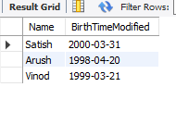
- DATE_SUB(): Subtracts a specified time interval from a date.
SELECT Name, DATE_SUB(dob, INTERVAL 1 YEAR) AS BirthTimeModified FROM user;
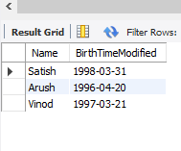

- DATEDIFF(): Returns the number of days between two dates.
SELECT DATEDIFF('2017-02-13','2017-01-03') AS DateDiff;
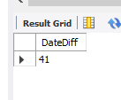
- DATE_FORMAT(): Displays date/time data in different formats.
SELECT DATE_FORMAT('1997-10-04 22:23:00', '%W %M %Y');
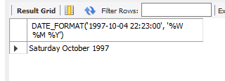

- DAYNAME(date):- Returns the name of the weekday for date.
SELECT DAYNAME('1998-02-05');
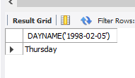
- DayOfMonth(Date):- Returns the day of the month for date, in the range 0 to 31.
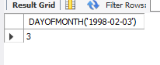

- DayOfWeek(Date):- Returns the weekday index for date (1 = Sunday, 2 = Monday, ., 7 = Saturday). These index values correspond to the ODBC standard.

SELECT DAYOFWEEK('1998-02-03');
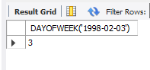
- DayOfYear(Date):- Returns the day of the year for date, in the range 1 to 366.
SELECT DAYOFYEAR('1998-02-03');
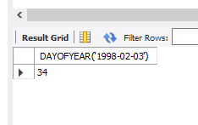
- MakeDAte(year,dayofyear):- Returns a date, given year and day-of-year values. The dayofyear value must be greater than 0 or the result will be NULL
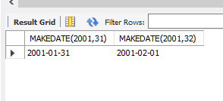

- MakeTime(hour,minute,second):- Returns a time value calculated from the hour, minute and second arguments.
SELECT MAKETIME(12,15,30);
